**P3.1 Evaluate the project using PERT**

**1.0 PERT**

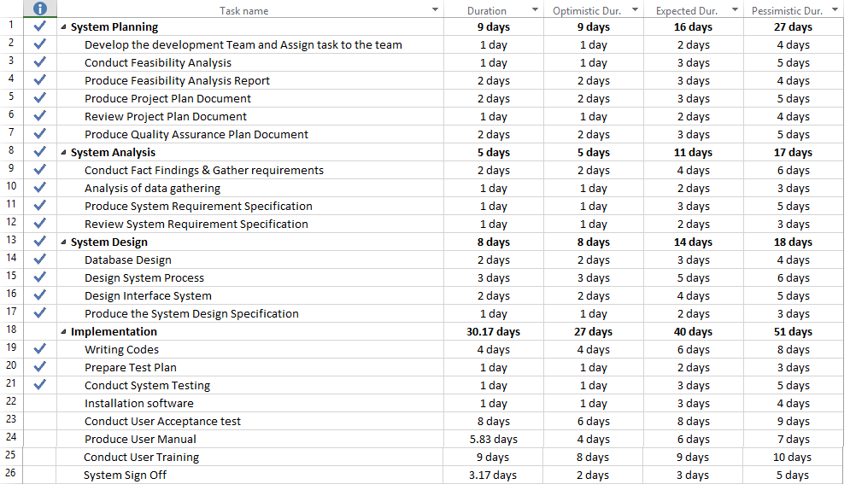 **1.1 Entry Form**

**Diagram 1: Entry Form for e-Donation Application**

**1.2 Network Diagram**

**Refer to the appendices**

**1.3 Explanation based on Entry form and Network Diagram**

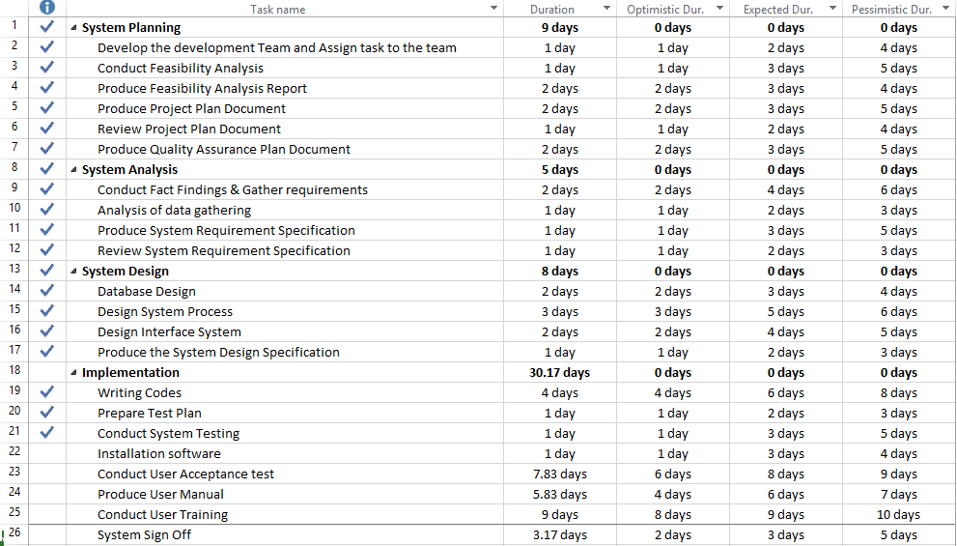 **1.3.1 Shortest Time to Finish**

**Diagram 2: Shortest time to finish task**

**Optimistic duration** is the minimum estimated time required to accomplish a task. (Sites.google.com, n.d.). Based on the diagram above, optimistic duration time to accomplish the task of producing system requirement specification is 1 day while the longest duration time to complete this task is 5 days.

**1.3.2 Sequence of task**

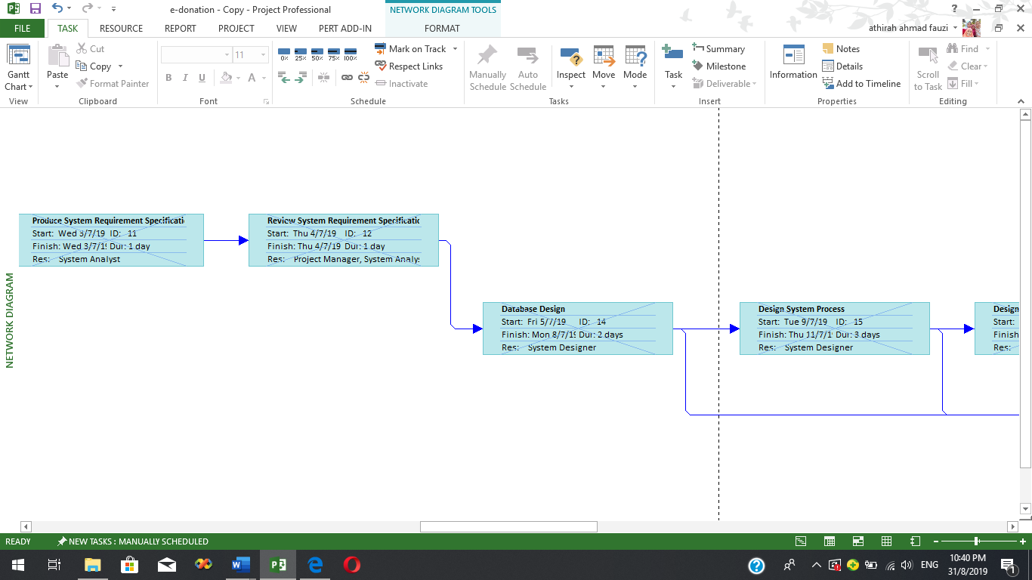**Diagram 3: Sequence of task**

**Sequence of task** can be referred as task dependencies in which a preceding task is depend with succeeding task in order to complete the preceding task (Projectinsight.net, 2019). Based on the diagram 3, there is task involved in developing e-Donation Application. The task of database design is depending to task of review system requirement specification. The task of database design could not be proceed until the task of review system requirement specification is completed.

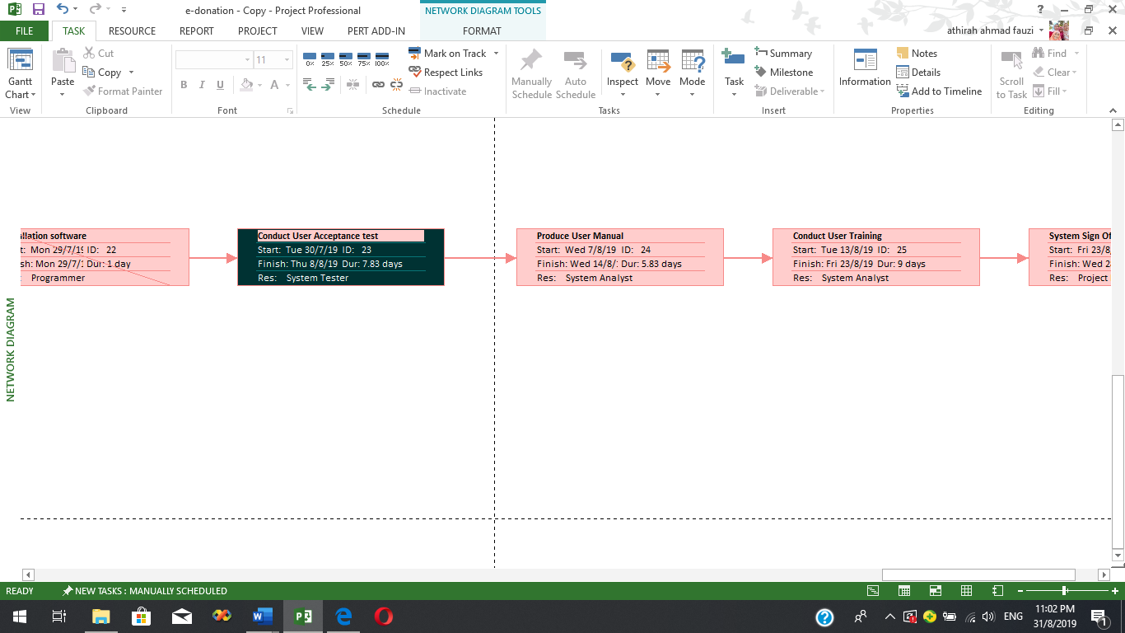**1.4 Critical task**

**Diagram 4: Critical task**

**Critical task** can be defined as a task that must be performed and completed on time without delaying it because it has no slack time. If the task is delayed, it will affect the entire project. Based on the Diagram 4, the task of produce user manual could not be delayed and must be performed on time as to avoid any effect of delay to the entire project of developing e-Donation Application.

**P3.2 Analyse and explain the results as compared to the project specification.**

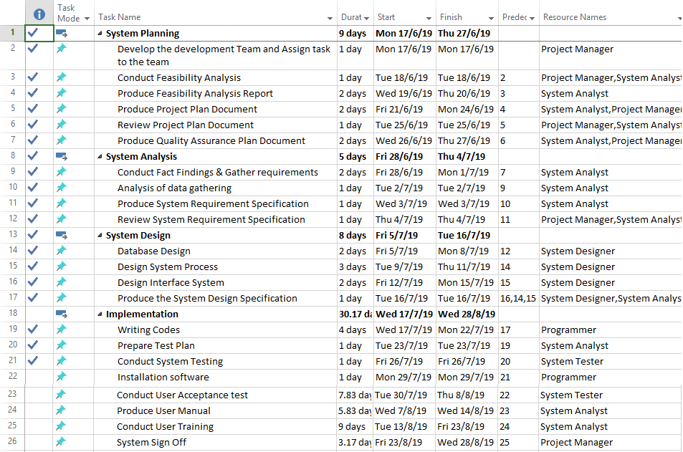**1.0 Project Specification**

**Diagram 5: Gantt Chart for e-Donation Application**

Diagram 5 shows the Gantt chart of e-Donation Application. Based on the diagram the first phase of developing e-Donation Application is System Planning. The first task in this phase is Develop the development Team and Assign task to the team. This task starts on 17th June 2019 and must be completed in one day. The next task is conduct feasibility analysis in which it starts on 18th June 2019 and must be completed in one day. Then, the next task is Produce Feasibility Analysis Report in which it will start on 19th June 2019 and must be completed in 2 days on 20th June 2019. Next task is Produce Project Plan Document. It starts on 21th June 2019 and must be completed in 2 days until 24th June 2019. The next task is Review Project Plan Document in which it starts on 25th June 2019 and must be completed in one day. The next day which is 26th June 2019, the Produce Quality Assurance Plan Document must be started and must be accomplished in 2 days on 27th June 2019.

The next phase in developing e-Donation Application is System Analysis. The first task in this phase is Conduct Fact Findings & Gather requirements. This task starts on 28th June 2019 until 1st July 2019 and this task takes 2 days to be completed. The next task in this phase is Analysis of data gathering. This task starts on 2nd July 2019 and must be completed in one day. The next task is Produce System Requirement Specification in which it starts on 3rd July 2019 and also must be completed in one day. Then, the last task in this phase is Review System Requirement Specification in which it will start on 19th June 2019 and takes one day to be accomplished.

Then, the next phase in developing e-Donation Application is system design. The first task in this phase is Database Design. This task starts on 5th July 2019 until 8th July 2019 and this task takes 2 days to be completed. The next task in this phase is Design System Process. This task starts on 9th July 2019 and must be completed in 3 days on 11th July 2019. The next task is Design Interface System in which it starts on 12th July 2019 and this task takes 2 days to be accomplished on 15th July 2019. Then, the last task in this phase is Produce the System Design Specification in which it will start on 16th June 2019 and takes one day to be accomplished.

The next phase in developing e-Donation Application is implementation. The first task in this phase is Writing Codes in which it starts on 17th July 2019 until 22nd July 2019 and this task takes 4 days to be accomplished. The next task is Prepare Test Plan in which it starts on 23rd July 2019 and must be completed in one day. Then, the next task is Conduct System Testing in which it will start on 26th July 2019 and must be accomplished in one days. Next task is Installation software. It starts on 29th June 2019 and must be completed in one day. The next task is Conduct User Acceptance test in which it starts on 30th July 2019 and must be completed in 8 day until 8th August 2019. The next task is Produce User Manual in which it starts on 7th August 2019 and this task takes 5.88 days to be accomplished until 14th August 2019. The next task is Conduct User Training in which it starts on 13th August 2019 and this task takes 9 days to be accomplished until 23rd July 2019. Then, the last task in this phase is System Sign Off in which also will start on 23th June 2019 and takes 3.17 day to be accomplished until 28th August 2019. Overall, the development of e-Donation Application has 52.17 days to be completed. The actual deadline for the entire project is on 28th August 2019.

**2.0 Current Progress of Project**



**Diagram 6: Structure of dependencies**

**Dependency** can be referred to the task which is depended to another task and it is relate with the predecessor in which refer to the task that have completed. The task must be completed before the depended task can be proceed. Based on the Diagram 6, Database Design is depended to Review System Requirement Specification. Database Design cannot be proceed unless Review System Requirement Specification is completed.

**3.0 Completed Task**

**Diagram 7: Completed Task**

Diagram 7 shows all the task that has be completed in the process of developing e-Donation Application. All the completed task in the Gantt Chart is showed by the tick. Based on the Diagram, all the task in System Planning phase is 100% complete. The task involved in this phase is Develop the development Team and Assign task to the team, Conduct Feasibility Analysis, Produce Feasibility Analysis Report, Produce Project Plan Document, Review Project Plan Document and Produce Quality Assurance Plan Document.

The next phase is System Analysis. The task involved in this phase is Conduct Fact Findings & Gather requirements, Analysis of data gathering, Produce System Requirement Specification and Review System Requirement Specification. All the task in this phase is completed 100%.

The third phase in this development is System Design. The task involved in this phase is Database Design, Design System Process, Design Interface System and Produce System Design Specification. All the task is 100% completed.

The next phase in this development is implementation. There are only few tasks involved in this phase which has been completed 100%. The task is Writing Codes, prepare Test Plan and Conduct System testing. While, Installation software is only 50% completed. The other task such as Conduct User Acceptance test, Produce User Manual, Conduct User Training and System Sign Off is not complete yet.

**4.0 Task in progress**

**Diagram 8: Task Progress**

Diagram 8 shows the task that is in progress. There are few tasks that is still not complete and still in progress. Installation software is the task that is still in progress and has 50% completed. While the other task which is Conduct User Acceptance test, Produce User Manual, Conduct User Training and System Sign Off is 0% completed and need to be completed by 28th August 2019.

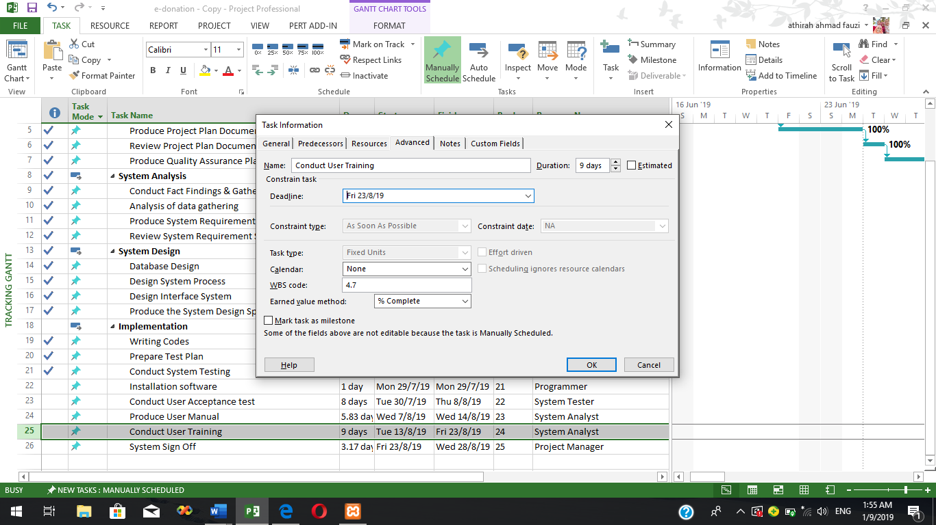**5.0 Task constraints**

**Diagram 9: Task Constraints**

Task constraint is referred to the restriction of task schedule which require the start or finish date of a task that is no later than, no earlier than and must be on a specific date (Project.net, n.d.). So, the task will not delay subsequent task. The task of Conduct User Training is set as ‘As Soon As Possible’. The task must be performed and finished at least 23rd August 2019.

**6.0 Critical Task.**

**Diagram 10: Critical Task**

**Critical task** can be defined as a task that must be performed and completed on time without delaying it because it has no slack time. If the task is delayed, it will affect the entire project. Based on the Diagram 4, the task of produce user manual could not be delayed and must be performed on time as to avoid any effect of delay to the entire project of developing e-Donation Application.

**7.0 Level of difficulty & accomplish according to the schedule plan with available sources.**

**7.1 Installation software**

The level of difficulty for installation software is **high**. It is because this task requires expertise that can handle the system installation. Lack of expertise can lead to the improper installation which can affect the system functionalities. So, for e-Donation Application, the available sources for the installation is already equipped and trained to has a proper skill so that it can manage any possible errors during the installation. Thus, the task can be completed within the planned schedule with the available sources.

**7.2 Conduct Acceptance Test**

The level of difficulty for conduct acceptance test is **medium**. It is medium because this task requires few end users that is responsive to use and test the system. Inadequate of responsive end user can lead to the incomplete software which is not meet the user requirement. It is because without responsive end user, the programmer will not receive a good feedback. So, for e-Donation Application, the available sources for conducting acceptance test is already equipped with good communication skill in which they can communicate with the end users to ask about the system functional and performance. By this, the task can be accomplished with within the schedule plan with the available sources.

**7.3 Produce User Manual**

The level of difficulty for produce user manual is **medium**. It is because this task requires expertise to make sure that the user manual will be produced sufficiently and correctly which can be understand easily by the user. Inadequate of expertise can lead to the insufficient of information and wrong format of the documentation. This task also may not be able to be accomplished on time. So, for the development of e-Donation Application, the available sources that is assigned to produce user manual is already equipped with full of understanding of the system which include the flow and the functional of the system. So that, this task can be completed successfully by the available sources within the planned schedule.

**7.4 Conduct User Training**

The level of difficulty for conduct user training is **medium**. It is high because this task requires expertise who has good communication skill expert about the system functionality to make sure that the user of the system could understand on how to use the system from the expertise’s explanation. The lack of good communication skills in expertise can lead to the poor user training which can affect the user of not being able to use the system. So, for e-Donation Application, the available sources who conduct this task is already has good communication skill in which they can train the user appropriately to ensure that the user can understand on how to handle the system. By this, this task can be completed within the planned schedule by the available sources.

**7.5 System Sign Off**

The last critical task for this project is system sign off. The level of difficulty for this task is **high**. It is high because this task requires expertise that know all the procedure and complete all related task before the system is delivered to the client. So that, all the task can be completed and verified by client. Inadequate of expertise in handling the system sign off will affect the process related to the system sign off. For e-Donation Application, the available sources who conduct this task is already has good and skilful in order to handle the system sign off by checking the overall system functionality and performance. By this, this task can be completed within the planned schedule by the available sources.

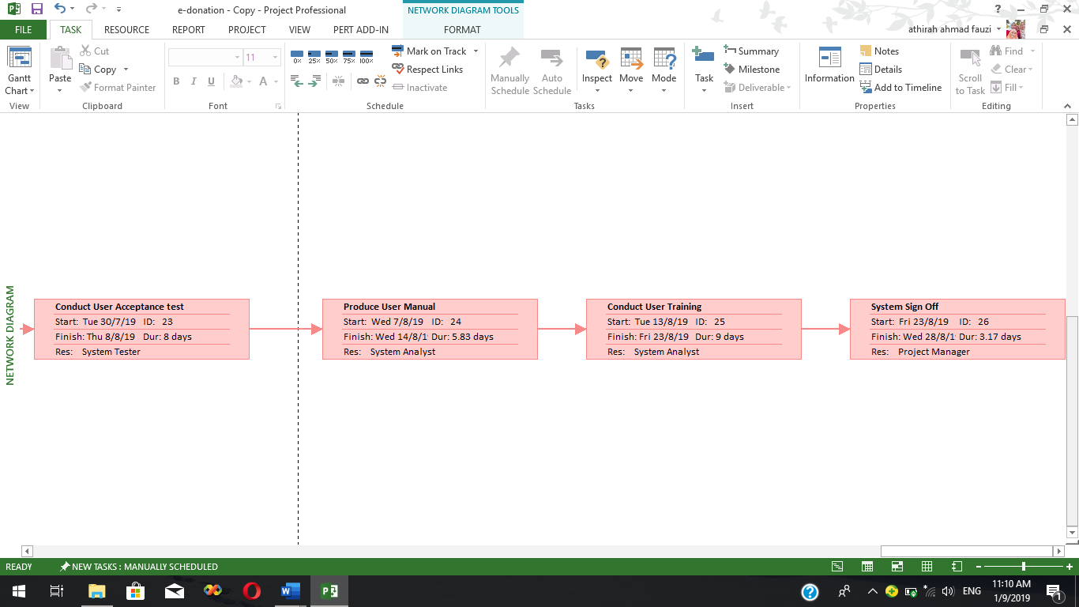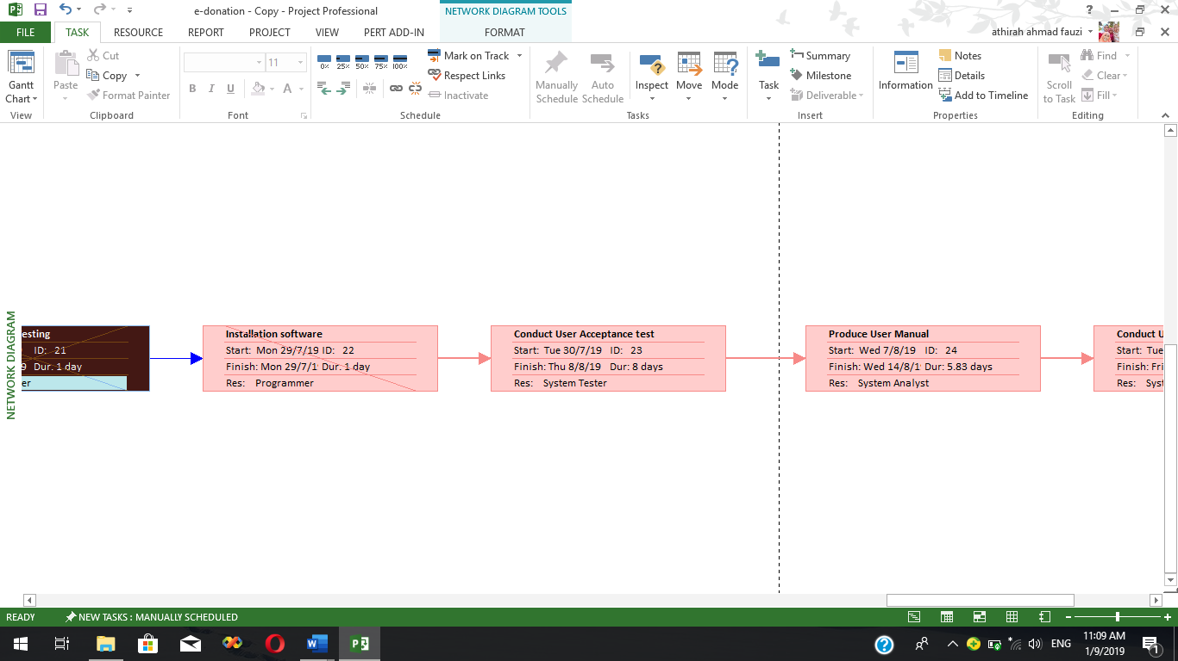**8.0 Critical Task Status**

**Diagram 11: Critical Task status**

**8.1 Critical task status**

1. Installation Software – Has started
2. Conduct User Acceptance test – Not started yet but still following the schedule
3. Produce User Manual – Not started yet but still following the schedule
4. Conduct User Training – Not started yet but still following the schedule
5. System Sign Off - Not started yet but still following the schedule

The action that can be done if the status of task is delay is the development team should shorten the subsequent task. The team should shorten the period of time for the next task if the current task is delay. This is to ensure that the project of developing e-Donation Application can be done within the deadline. The other action that can be taken if the status of the task is delayed is by recruiting temporary resources. HyperIT Tech Bhd should hired temporary workers to lighten the delay task and support the load of the other task. This is to ensure that the project can be done within the deadline because the temporary worker can help the other resources to reduce the workload. (Bright Hub PM, n.d.)

**P3.3 Recommendation for improvement**

Based on Diagram 11 and analysis that has been done, there is no recommendation for improvement for the critical task and all the other task. It is because all the tasks have been completed within the schedule and the critical task can be completed and can be proceed within the schedule even though the task is not started yet. It is because all the available resources have been equipped with good skill that can handle all the critical task. So, all the task can be finished on the deadline.

**P3.1 Evaluate functionalities using UAT (User Acceptance Test).**

**1.0 UAT Sample**

|  |  |  |  |  |  |  |  |  |  |  |  |  |  |
| --- | --- | --- | --- | --- | --- | --- | --- | --- | --- | --- | --- | --- | --- |
| **Project Name:** | e-Donation Application | **Version Number:** | 1.0 | **Programmer’s Name:** | | | Pavitra | | | **Machine Specification:** | | | OS: Window 10  Software: Adobe Dreamweaver |
| **Client’s name:** |  | | | **Test date:** | | |  | | | | | | |
| **Test Case Id** | **Test Case Description** | | | | **Rating** | | | | | | | **Remark** | |
| **1** | **2** | | **3** | **4** | | **5** |  | |
| Functionality Suitability | | | | | | | | | | | | | |
| FS01 | **Functional Correctness**  Does e-Donation Application produce correct report based on the selected Organization/Department? | | | |  |  | |  |  | |  |  | |
| FS02 | **Functional Completeness**  Does functions of e-Donation Application cover all the specified tasks and user objectives together with the requirements? (eg: maintain donation request approval and generate report of donation?) | | | |  |  | |  |  | |  |  | |
| FS03 | **Functional appropriateness**  Does the functions in the e-Donation Application facilitate the accomplishment of the specific task? (eg: Add new donation request) | | | |  |  | |  |  | |  |  | |
| Usability | | | | | | | | | | | | | |
| U01 | **Appropriateness Recognizability**  Does user can recognize whether the system is appropriate for their needs? | | | |  |  | |  |  | |  |  | |
| U02 | **Operability**  Does user can easily operate and control the system? | | | |  |  | |  |  | |  |  | |
| U03 | **User interface aesthetics**  Does layout, color and font used in e-Donation Application is pleasing and satisfying interaction for the user? | | | |  |  | |  |  | |  |  | |
| U04 | **Learnability**  Does the guidelines in the Sign up page and Add New Donation Request page help you to enter the information easily and efficiently. | | | |  |  | |  |  | |  |  | |
| Security | | | | | | | | | | | | | |
| S01 | **Confidentiality**  Does the login function in e-Donation Application ensure that the data are accessible only to those authorized to have access to the system? | | | |  |  | |  |  | |  |  | |
| S02 | **Integrity**  Does password used in e-Donation Application prevent any modification to data? | | | |  |  | |  |  | |  |  | |
| Performance Efficiency | | | | | | | | | | | | | |
| PE01 | **Time Behavior**  Does the response and processing times and throughput rates of e-Donation Application is fast when it is performing its functions? | | | |  |  | |  |  | |  |  | |

**P3.2 Analyse and explain the result**

Based on the User Acceptance Test that has been conducted for e-Donation Application, there is 10 question that has been asked. All the question has been produced based on the characteristic in the ISO/IEC 25010 standard. There are 4 characteristic that has been used from the standard. The characteristic is Functional Suitability, Usability, Security and Performance Efficiency. There are 6 respondents that has answered all the 10 questions and all the respondents are the student of KPM Beranang.

**2.1 Result from UAT**

**2.1.1 Functionality Suitability**

From this characteristic, there are 3 questions that has been asked based on the sub-characteristic in this characteristic. The first question in which the test case ID is FS01, there are 6 respondents and all of them have rated 5 on the functional correctness of the system. This can be concluded that e-Donation Application has successfully produced the correct report based on the selected Organization/Department.

The other question which is the test case ID is FS02, there are 3 over 6 respondents have rated 4 and the other 3 respondents have rated 5 on the functional completeness of the system. This can be concluded that function in e-Donation Application is successfully covers all the specified tasks and user objectives together with the requirement.

The next question which is the test case ID is FS03, there are 5 respondents over 6 have rated 5 on the functional appropriateness. While the other 1 respondent has rated 4. This can be concluded that the functions in e-Donation Application is successfully facilitate the accomplishment of the specified task such as add new donation request.

**2.1.2 Usability**

From this characteristic, there are 4 questions that has been asked based on the sub-characteristic in this characteristic. The first question in which the test case ID is U01, there are 6 respondents and all of them have rated 5 on the appropriateness recognizability of the system. This can be concluded that the user can successfully recognized the system appropriate for their needs.

The next question which is the test case ID is U02, there are 5 respondents over 6 have rated 5 on the operability. While the other 1 respondent has rated 4. This can be concluded that the user can easily operate and control the system.

The other question which is the test case ID is U03, there are 6 respondents and all of them have rated 5 on the user interface aesthetic of the system. This can be concluded that the e-Donation Application has pleasing and satisfying layout, colour and font for user interaction.

The last question for this usability characteristic which is the test case ID is U04, there are 5 respondents over 6 have rated 5 on the learnability. While the other 1 respondent has rated 4. This can be concluded that the guideline in Sign Up page and Add New Donation Request page can successfully help the user to enter the information easily and efficiently.

**2.1.3 Security**

From this characteristic, there are 2 questions that has been asked based on the sub-characteristic in this characteristic. The first question in which the test case ID is S01, there are 6 respondents and all of them have rated 5 on the confidentiality of the system. This can be concluded that the login function in e-Donation Application can successfully ensure that the data are accessible only to those authorized to have access to the system.

The last question for this security characteristic which is the test case ID is S02, there are 6 respondents and all of them have rated 5 on the integrity of the system. This can be concluded that the password used in e-Donation Application can successfully prevent any modification to data.

**2.1.4 Performance Efficiency**

From this characteristic, there are a question that has been asked based on the sub-characteristic in this characteristic. The question in which the test case ID is PE01, there are 6 respondents and all of them have rated 5 on the time behaviour of the system. This can be concluded that the time respond and processing times and throughput rates of e-Donation Application is fast when it performed its function.

**P3.3 Recommend improvements and justify**

**3.0 Recommend improvements and justify**

3.1 Input

* Donation Information
* Applicants Information
* Program Information

3.2 Output

* Report of donation request by Organization/Department

3.3 Data

* Applicant information – Name, IDNo, Password, ICNo, PhoneNo, Email and UserType
* Donation Information – IDNo, ApprovalStatus, AmountOfDonation and ProgramID
* Program Information – ProgramTitle, ProgramID, DateOfProgram, AmountOfStudent, Attachment and Organization/Department

3.4 Function/Process

* User authorization by using IDNo and Password for applicants and manager of the system which is members of Koperasi KPMB.
* Maintain (add, delete, update) donation request
* Maintain (update) member and Applicant’s Information
* Print/Generate report of donation request
* Record donation request
* View Donation Approval

3.5 User Interfaces requirement

* + Consistency in each page: The system’s language, layout, button and navigation menu will be consistent in each page to make sure that user can use the system efficiently.
  + Simple Interface: The system will use simple and clear elements to ease users to use the system and all the words used in the system are easy to be understood.
  + Colour and texture: The system will use contrast and light colour for the background to make sure users can read the words in the system clearly. The colour used for the background is white while for the words is black.

Based on the User Acceptance Test that has been conducted, the overall functionality, usability and performance of e-Donation Application and project specification is meet with the user requirement. It is because based on the analysis of the UAT, most of the question provided has been rated 4 and 5 only. it showed that the system has fulfil all the user requirement. The system has been implemented with all the input, output, data, function/process and user interface requirement that has been stated in SRS. But there is some improvement that could be made. The system should be implemented with the functionality that can generate report by monthly and yearly. This will ease the user to track the donation request made by applicant. So, the member of Koperasi KPM Beranang can easily know how many donations that has been made on the selected month and year. So, the improvement could be made in the future to make the system become more efficient.

**Produce complete documentation for procedures used during your project development. (P4.1)**

Project Management Procedures articulates the processes that are carried out throughout a project's life to ensure the efficient and effective management of all projects. There are two type of project management procedure that can be applied for e-Donation Application which is Issue (Problem) Management Procedure and Risk Management Procedures. (Policies.anu.edu.au, n.d.)

**Issue (Problem) Management Procedure**

1. Obtain potential issues such as inadequate funding from any project stakeholders, including the project team. It must be formally documented using an Issue Submission Form.
2. Enter the potential issue which is inadequate funding into the Issues Log.
3. Assign the issue of inadequate funding to a project team member for investigation. The team member will investigate options that are available to resolve the issue. For example, determine the financial priorities in which prioritize the task that used high cost. For each option, they should also estimate the impact to the project in terms of budget, schedule, and scope.
4. The multiple options and the effect on schedule and budget are recorded in the Issue Submission Form.
5. If resolving the issue of inadequate funding will involve changing the scopein e-Donation Application, close the issue of inadequate fundingnow and use the scope change management procedures.
6. Document the resolution or course of action of determine the financial priorities on the Issue Submission Form.
7. Document the issue resolution which is determine the financial priorities briefly on the Issues Log.
8. Make the appropriate adjustments to the work plan and project budget, if necessary.
9. If the resolution of the issue which is determine the financial priorities causes the budget, effort, or duration of the project to change, the current Project Definition must be updated.
10. Communicate by using video conferencing via Skype to discuss issue status and resolutions of determine the financial priorities to project team members and other appropriate stakeholders.

**Risk Management Procedures**

1. Perform a complete assessment of project risk such as hacker.
2. Assign a risk level to each risk identified. For computer criminal the level of the risk is high.
3. A response plan must be created for each high-level risk that has been identified to ensure the risk can be managed successfully. This plan should include steps to manage the risk, people assigned, completion dates, and periodic dates to monitor progress. If the identified risk which is hacker is high level, so the response plan is to implement the system with password which require special character such as *_^#$%.
4. Evaluate the medium-level risks to determine if the impact is severe enough that they should have a risk response plan created for them as well.
5. Look at any low-risk items and see whether they should be listed as assumptions. In this way, potential for problems are recognized, but because the risk of hacker is low level make assumption that the condition will not occur.
6. Move the activities associated with the risk plans. The identified risk which is hacker is high level so the programmer should implement the system with password that require special character such as *_^#$% to the project workplan.
7. The project manager needs to monitor the risk plans. If identified risk which is hacker is high level, the programmer should implement the system with password that require special character such as *_^#$% to ensure they are being executed successfully.
8. The project manager also needs to periodically evaluate risks throughout the project based on current circumstances.

**Demonstrate your project to users using appropriate media and produce user manual for the project. (P4.2)**